**Linux Shell Script Program Assessment**

1. Create a Linux shell script program to swap two numbers.

Input:

read -p " Please enter the first number " First

read -p " Please enter the second number " Second

Temp=$First

First=$Second

Second=$Temp

echo " After swaping, numbers are "

echo " First=$First , Second=$Second "

Output:

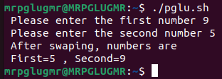

1. Create a Linux shell script program to print whole number.

Input:

i=0

while [ $i -ge 0 ]

do

echo " $i "

((i++))

done

Output:

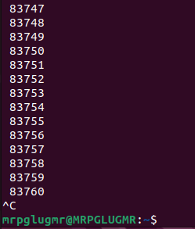

1. Create a Linux shell script program to print prime number.

Input:

read -p " Enter a Value " n

for((i=2; i<=$n/2; i++))

do

a=$(($n%i));

if [ $a -eq 0 ]

then

echo " $n is not a Prime number "

exit 0

fi

done

echo " $n is Prime number "

Output:

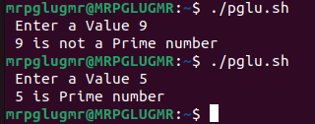

1. Create a Linux shell script program to print natural number.

Input:

i=1

while [ $i -ge 0 ]

do

echo " $i "

((i++))

done

Output:



* 1. Create a Linux shell script program to print even & odd number.

Input:

read -p "Enter a number: " A

B=$(($A%2))

if [ $B -eq 0 ]

then

echo " Number $A is Even "

else

echo " Number $A is Odd "

fi

Output:

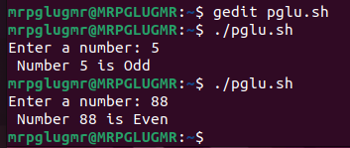

1. Create a Linux shell script program to print read two integer numbers and print the subtraction of both the numbers.

Input:

read -p " Please enter the first value " A

read -p " Please enter the first value " B

Sub1=$(($A-$B))

Sub2=$(($B-$A))

if [ $A -gt $B ]

then

echo " Subtraction of both the number = $Sub1 "

else

echo " Subtraction of both the number = $Sub2 "

fi

Output:

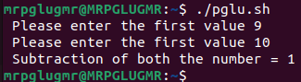

1. Create a Linux shell script program to take a number from the user and check whether the number is greater than 20 or not.

Input:

read -p " Enter a Value " A

if [ $A -gt 20 ]

then

echo " $A is grater then 20 "

else

echo " $A is not grater then 20 "

fi

Output:

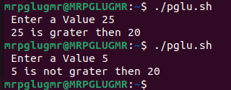

1. Print a table of 13 using forloop.

Input:

for i in 13 26 39 52 65 78 91 104 117 130

do

echo " $i "

done

Output:

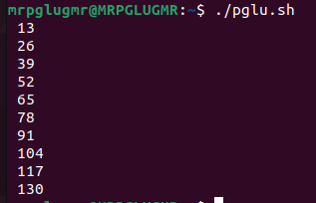

1. Print numbers from 1-10 using "C style forLoop".

Input:

for i in {1..10}

do

echo " $i "

done

Output:

